**Command line Arguments**

* Arguments passed from command prompt to main method are called command line argument.

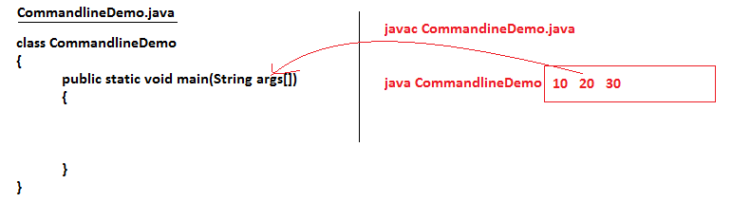

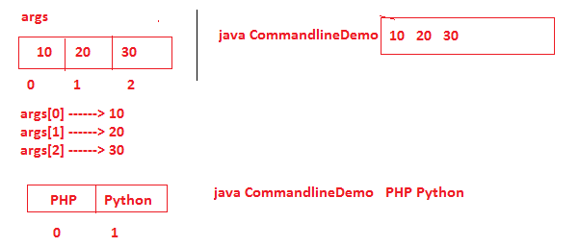

**Program#1**

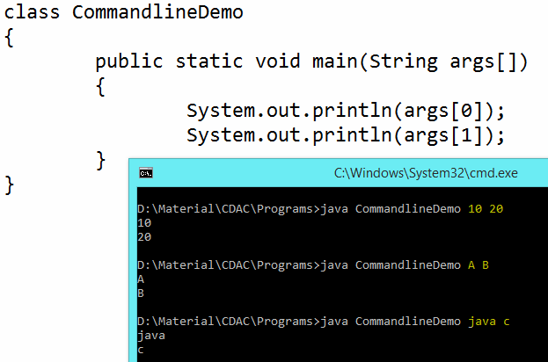

**Note**

* Command line arguments are separated with space.
* If command line argument contains space then keep it with in double quote.



**Identifiers**

* Any name in the java program like class name, method name, variable name is called identifier.

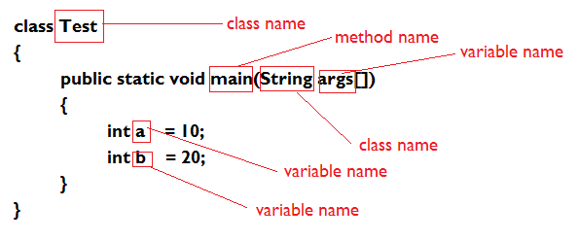

**Rules to declare identifiers**

* Allowed character set for variable names are a-z, A-Z,0-9,_ (underscore symbol) and $ (dollar symbol).
* The java identifiers should not start with numbers.
* Space and Special character are not allowed.
* The identifiers are case sensitive.
* It is possible to declare all the predefined class names as a identifier. But it is not recommended to use.

**Variable**

* Variables are the name of the memory location used to stores data temporarily which value can changes.

**Types of variable**

* Local Variable
  + The variables which are declare inside a method are called local variables.
* Instance Variable
  + The variables which are declare inside a class and outside of methods are called instance variable.

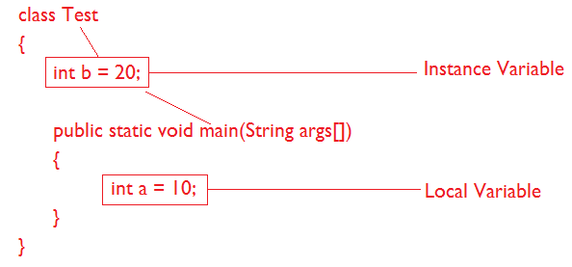

**Data Type**

* Data type decides the type of data that can store in the corresponding memory location.

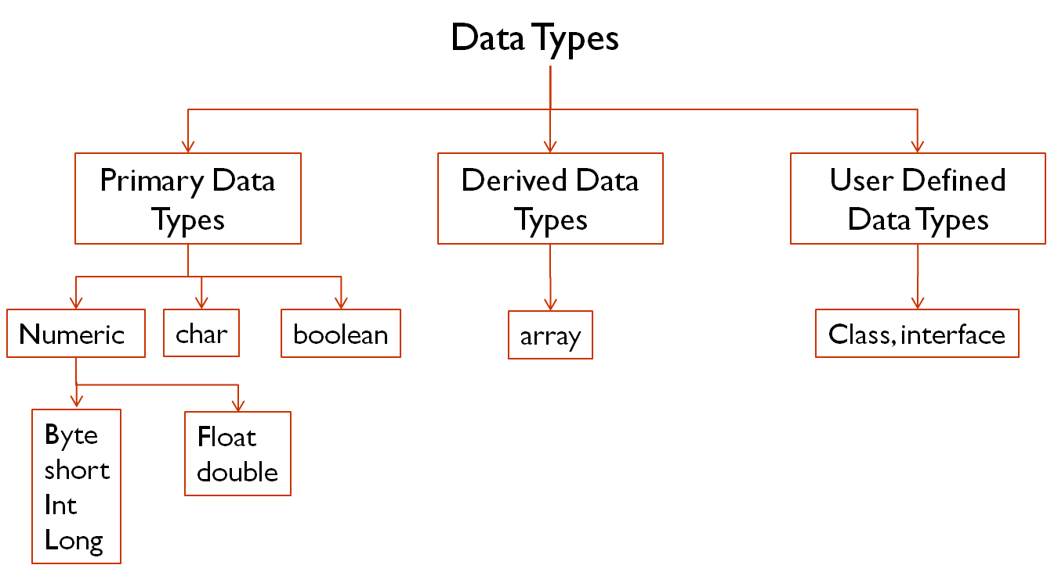

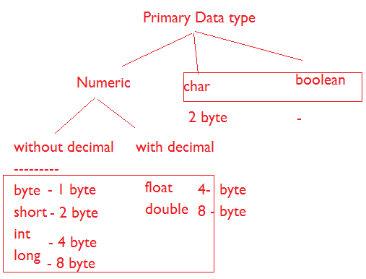

**Operator**

* Operator is a symbol that acts upon the operands to carry out certain type computations.
* A variable or constant otherwise known as operand.

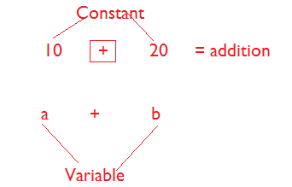

**Types of Operator**

* Unary Operator
  + Operator associated with one operand is known as unary operator.
* Binary Operator
  + Operator associated with two operands is known as Binary Operator.
* Ternary Operator
  + Operator associated with three operands is known as Ternary Operator.

**Increment Operator / Decrement Operator**

* Increment Operator
  + It is used to add 1 to the exiting value of the variable.
* Decrement Operator
  + It is used to subtract 1 from the value of the variable.

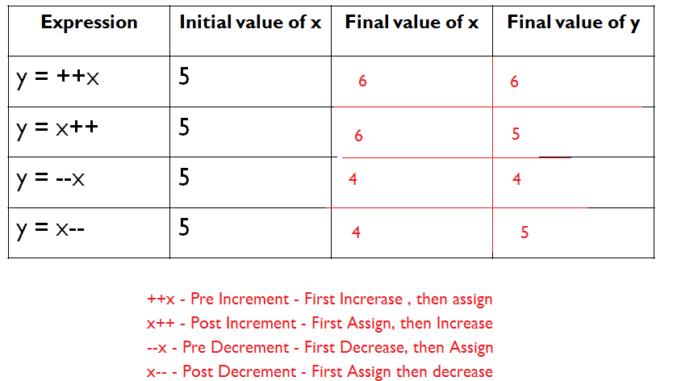

**Case1:**

* We can apply increment and decrement operator only for variables but not for constant values.

class Test

{

public static void main(String args[])

{

int x = 4;

int y = ++10;

System.out.println(y);

}

}

**Case2:**

* Nesting of increment and decrement operators is not allowed.

class Test

{

public static void main(String args[])

{

int x = 4;

int y = ++(++x);

System.out.println(y);

}

}

**Case3:**

* We can't apply increment and decrement operators for the final variable.

class Test

{

public static void main(String args[])

{

final int x = 2;

x++;

System.out.println(x);

}

}